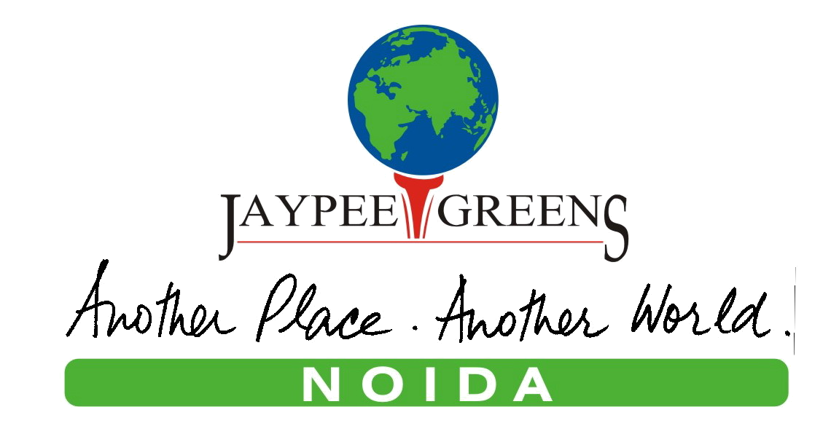

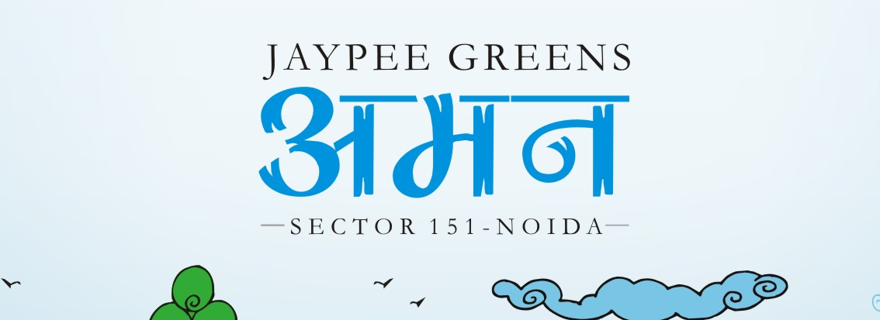

Sector 151, Noida

INFOPACK

List of contents

1. Product brief: Page 3

2. Specifications: Page 4 - 5

3. Price list: Page 6 – 8

4. FAQ’s: Page 9 - 11

PRODUCT BRIEF

Jaypee Aman – 3,300 apartments sold in a single day.

Jaypee Aman Location: Sector 151, Noida

Features of Jaypee Greens 

- Spread across 70 acres
- Flanked by thematic gardens
- 9-hole pitch & putt golf course
- Ample car park spaces with reserved parking and visitor parking
- 2 BHK and 3 BHK Apartments
- Crèche, nursery to senior secondary education facilities
- 24x7 power and water supply
- 7.4 kms from upcoming Formula1 track.
- Located in Sector 151, connected through 45 meters wide sector road from the Noida – Greater Noida Expressway. Just 30 minutes driving distance from South Delhi
- Better connectivity through the proposed Delhi Metro & Yamuna Expressway.
- Close proximity to SEZ’s & commercial areas.

Type of Apartments:

Apartments | Area
2 BHK | 850 sq ft
3 BHK | 1200 sq ft
3 BHK + worker’s room | 1320 sq ft

Number of floors: G +20

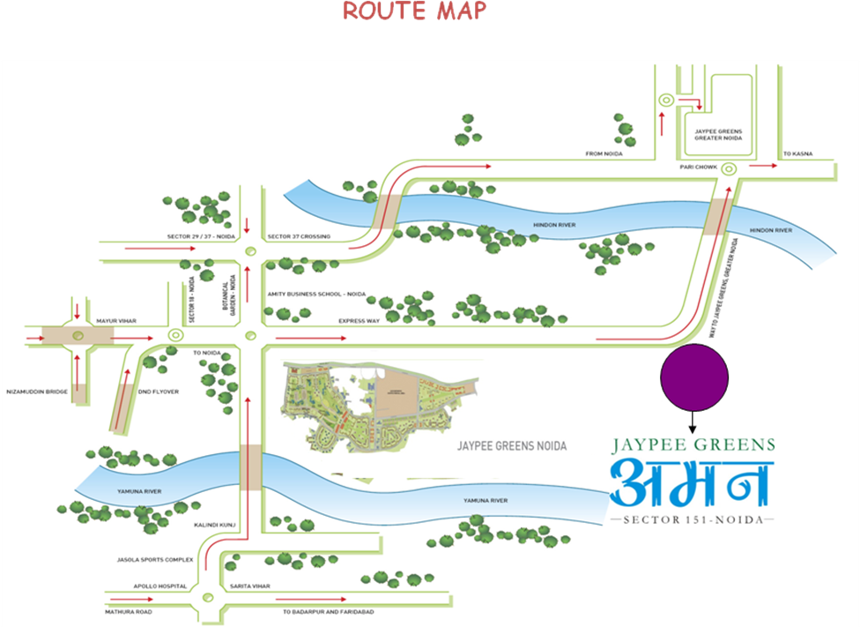

SPECIFICATIONS FOR JAYPEE GREENS
STRUCTURE | R.C.C Framed Structure
LIVING ROOM, DINING ROOM & LOUNGE
Floors | Tiles / laminated floor / mosaic
External Doors and Windows | Window- pre-engineered steel frame with wooden shutters  Doors- flush doors
Walls | Internal : Oil Bound Distemper
 | External : Good Quality external grade paint
Internal doors | Enamel painted Flush doors
BEDROOMS & DRESS
Floors | Tiles / laminated floor
External Doors and Windows | Window- pre-engineered steel frame with wooden shutters  Doors- flush doors
Walls | Internal : Oil Bound Distemper
 | External : Good Quality external grade paint
Internal doors | Enamel painted Flush doors
TOILETS
Floors | Vitrified Tiles
External Doors and Windows | Window- pre-engineered steel frame with wooden shutters  Doors- flush doors
Fixture and Fittings | All provided of Standard Company make
Walls | Tiles in cladding up to 7' in shower area and 3'-6" in balance areas, Balance walls painted in Oil bound distemper
Internal doors | Enamel painted Flush doors
KITCHEN
Floors | Vitrified Tiles
External Doors and Windows | Window- pre-engineered steel frame with wooden shutters  Doors- flush doors
Fixture and Fittings | Stone Top with sink
Walls | Ceramic Tiles 2'-6" above counter, Balance walls painted in Oil Bound Distemper
BALCONIES/ VERANDAH
Floors | Ceramic / Vitrified Mosaic Tiles
Railings | MS Railing as per Design
LIFT LOBBIES / CORRIDORS
Floors | Ceramic / Mosaic Tiles / Marble / Kota or equivalent
Walls | Oil Bound Distemper

Price List
Jaypee Greens
BSP: Rs 2400/- psf

Other Applicable Charges:

S. No. | Payment Head | Charges / Rate
1 | Internal Development Charges | Rs. 75.00 psf
2 | External Development Charges | Rs. 75.00 psf
3 | Electric Sub Station Charges | Rs. 40.00. psf
4 | Social Club Membership | Rs. 1.50 Lac
5 | Car Parking | Rs. 1.50 lac (One reserved basement car parking space compulsory with any apartment)
6. | Interest Free Maintenance Deposit | Rs. 50.00 psf
7. | Preferential Location Charges | Rs. 150 psf (Ground Floor)  Rs. 100.00 psf (1st -5th floor)  Rs. 60.00 psf (6th – 10th floor)
8. | One time lease rent | Rs. 50.00 psf
9. | Transfer charges | Free

Notes:
- The Basic Prices are for the indicated Super area and are not inclusive of charges for the reserved car parking slot, land development charges, electric sub-station charges.
- Additional amounts towards Stamp Duty, Registration Charges, and legal / miscellaneous expenses etc., shall be payable by the Allottee at the time of offer of possession.
- Maintenance charges as per maintenance agreement shall be payable by the allottee separately.
  - The interest free Maintenance deposit @ Rs. 50.00 per sq. ft. of super area shall be payable extra before handing over possession of the premises to the allottee.
- Areas are indicative only.
- Exact super area of Apartment shall be calculated at the time of handing over possession of property as constructed. Increased / decreased area shall be charged proportionately as per the sale price.
- The super area means the covered area of the demised premises inclusive of the area under the periphery walls, area under columns and walls within the demised premises, half of the area of the wall common with the other premises adjoining the demised premises, cupboards, plumbing / electric shafts of the demised premises, total area of the balconies and terraces, and proportionate share of the common areas like common lobbies, lifts, common service shafts, staircases, machine room, mumty, electric sub station and other services and other common areas etc.
- The other terms and conditions shall be as per the Application Form, Standard Terms and Conditions and the Allotment Letter of the Company.
- The prices are subject to revision / withdrawal at any time without notice at the sole discretion of the Company.
- Government Taxes as applicable from time to time shall be payable by the allottee in addition to the sale price as stated above.
- Transfer fees would be free & would be allowed only after 30% of the payment has been received from the allottee (subject to change, as per the company policy).

A. Construction Linked Plan
S No | Payment Due On | % age | Other applicable charges
1 | Booking amount | As applicable *
2 | On or before 2 months of the Application | 20% of BSP (Less booking amount*)
3 | On or before 4 months of the Application | 10% of BSP
4 | On commencement of excavation | 10% of BSP
5 | On laying of upper basement slab | 10% of BSP
6 | On laying of 1st floor Roof Slab | 7.5% of BSP | Car park charges
7 | On laying of 3rd floor Roof Slab | 7.5% of BSP
8 | On laying of 6th floor Roof Slab | 6.5% of BSP | IDC Charges
9 | On laying of 9th floor Roof Slab | 6.5% of BSP | PLC Charges as applicable
10 | On laying of 11th floor Roof Slab | 6% of BSP | Electric sub station charges
11 | On laying of top floor Roof Slab | 6% of BSP
12 | On completion of internal plaster & flooring within the apartment | 5% of BSP
13 | On offer of possession | 5% of BSP | Social Club Charges + IFMD + Lease rent
 | TOTAL | 100%

* Booking Amount:
2 BHK - Rs. 1.50 Lac
3 BHK & 3 BHK + worker’s room - Rs. 2.00 Lac

Cheque should be drawn in favour of ‘Jaypee Infratech Limited’

Notes:
- Installments under S. No. 4 - 13 may run concurrently with those under S. No. 1 - 3 based on the physical progress of Work at site.
- The demand letter for Installments at S. No. 4 to 13 shall be sent in advance providing for payment period of up to 15 days.

B. Down Payment Plan
S No | Payment Due On | % age | Other applicable charges
1 | Booking amount | As applicable *
2 | On or before 1 month of the Application | 95% of BSP (Less booking amount*) | IDC + Car park + Electric sub station charges +PLC
3 | On offer of possession | 5% | Social Club Charges + IFMD + Lease rent
 | TOTAL | 100%

Note: Down Payment Discount: @ 15% on BSP

JAYPEE GREENS - FAQS

Jaypee Greens offers perfect balance between life & leisure. It combines modern efficient interiors with spectacular surroundings which include landscaped parks & gardens, 9-hole pitch & put Golf Course, shopping complex, convenios, recreation clubs & more.

What is the exact location of this project? How far is it from Expressway?
- The project is located on the Noida-Greater Noida Express way, at sector 151, Noida. It’s a comfortable 15 minutes drive from the Noida DND flyway 40 minutes from Central Delhi.
- Its distance from the expressway is under a minutes drive.
- The under construction Formula 1 track is at a distance of approx 7.4 km.

Is it part of Wish Town or it’s a new project from Jaypee?

- Jaypee Greens is a 70 acre new project being launched by Jaypee. It offers best of facilities & services at affordable prices.

The Specifications & Facilities include the following:
  - Residential Real Estate as a mix of two, three and three bedroom + worker room family apartment complexes.
  - Recreational facilities like: Social Club with community gathering space, 9-hole pitch & put Golf Course, Kids Play Zone, etc.
  - Civic facilities like community retail, shopping complexes, banks, ATM’s, etc.
  - Institutional areas like schools, crèche, etc.
  - Tower Height : G+13 & G+17
  - Apartment Sizes : Super Area
2 BHK__________________850 sq ft
3 BHK__________________1200 sq ft
3 BHK + workers room_____1320 sq ft

How many apartments would be there on a floor?
There would be 6-8 apartments to a floor.

What is the delivery schedule of this product and project timelines?

The delivery schedule for Jaypee Greens would be about 30 months from date of launch.

Are you offering rental management services?
Jaypee might look at having an arrangement around possession, with an agency specializing in providing such services; like we have tied with CBRE, the facility management provider in Greater Noida, to provide rental services in future.

What is the Security System at ‘Jaypee Greens ’?
Jaypee Greens would offer multi-tier security system with Manned Security at the periphery of the complex and Access Control at the entry / exit gate of the complex

What is the provision for power and water back up?
The apartments would have 24x 7 power and water back up.

Who will maintain Common Areas? Do I pay anything upfront towards common area charges?
- The common areas/services will be maintained by a designated Maintenance Agency on payment of maintenance charges.
- The Interest Free Maintenance Deposit is payable upfront, as per the payment plan.
- The Maintenance Charges, are payable on a monthly basis. However, maintenance advance for one year is payable at the time of booking.

What is the number of reserved car parking spaces available with each unit? Can additional parking spaces be purchased?
Each apartment is provided with one compulsory underground reserved car parking space. Additional parking spaces can also be purchased as per availability.

How will service staff like maids, drivers, etc be given access?
All authorized service staff will be issued Identity Cards to facilitate their access in the premises.

PAYMENT RELATED QUERIES
Is the price escalation free?
Yes the contracted price would be escalation free.

Would I be required to pay any annual lease rentals?

Yes, there is a one time lease rent @ Rs. 50 psf.

What are the various payment plans available?
Up front and construction linked payment plans are being offered

What if there is a delay in payment on due date? Is any interest levied for the same?
All installments are payable by the due date. Any delay in payment beyond the due date will attract a penal interest @ 18 % p.a. on the delayed amount for the delay period.

Can I request for cancellation of allotment at a subsequent date? What are the financial consequences of the same?

A request for cancellation can be made at any time after allotment. It may however be noted that the Earnest Money (10% of total the consideration) will be forfeited as the same is non refundable.

Will it be comparable to the quality of construction that has been delivered earlier?
The quality and standard of construction will be comparable to the construction in our ongoing real estate projects.

Will there be any Preferential Location Charges applicable?

Yes, PLC is applicable as follows:
Ground floor @ Rs. 150 psf
1st – 5th floor @ Rs. 100 psf
6th – 10th floor @ Rs. 60 psf

Are there any transfer charges?

No, there is no first time transfer charge. However, Transfer would be allowed only after 30% of the payment has been received from the allottee.

Authorized Channel Partner


Head Office: 8th Floor, MSX II, Alpha Commercial Belt, Greater Noida (UP), India
Mobile: +91 9650791023 / 4 / 5. Phone +91 120 4505555

BOP Flagship Studio: 1st Floor, G-7, Sector 18, Noida (UP), India
Phone +91 120 4195555
E-mail:sg@bopgroup.in Website: www.jaypeeaman2.com

The brochure is conceptual and not a legal offer & gives only a bird’s-eye view of the project. The content in this brochure, including the buildings, elevations, area, designs, layouts, specification, etc. are tentative and are merely indicative in nature and are subject to variations and modifications by Jaypee Greens or the competent authorities, statutory and otherwise.

